**Financial Analysis on NWD’s ‘SKYCITY’ Project**

CB3410 Project Report



**Group members:**

She Xuan (55052988)

LEE CHEUK NAM (55676629)

ZOU Chuyang (56227312)

SHAN Jinyun (55670256)

SONG Jiaqi (56237110)

**Content**

1. Background
2. Method
3. Cash flow
4. Cash flow to creditors.
5. Cash flow to shareholders
6. Cash flow from assets
7. Revenue

i) Rental income

ii) Parking charge

iii) Retail income

1. Expense

i) Salary

ii) Depreciation

iii) Tax

1. Change in NWC
2. Base Best and Worst Scenario
3. Base
4. Best
5. Worst
6. Project cash flows and NPV
7. IRR and Loss
8. IRR
9. Loss
10. References

**1. Background**

The ‘SKYCITY’ project should have been a project with high profit and great influence, which New World Development has the contract to build. It would be a complex comprising retail, dining and entertainment facilities, transport terminals, and large amounts of car parking spaces, and offices may be included as well. Besides, it is expected to the largest retail complex and a landmark in Hong Kong because its geographical advantage could bring visitors from Hong Kong International Airport and the Greater Bay Area. As a result, NWD has invested much capital in this project. However, unexpected instability might cause overestimated in the profitability of this project. This report will reanalyze this project financially with the latest information.

**2. Method**

We consider the analysis of cash flow highly fundamental and important, so we try to make our analysis regarding cash flow well-grounded. During the process of the analysis, we find it difficult to directly obtain cash flow from assets. So, we use cash flow to shareholders and cash flow to creditors, which can be deduced from known data, to make adjustments to cash flow from assets, much information of which are unknown.

**3. Cash Flow**

**a) Cash Flow to Creditors**

Cash Flow to Creditors = Interest paid - Net New Borrowing

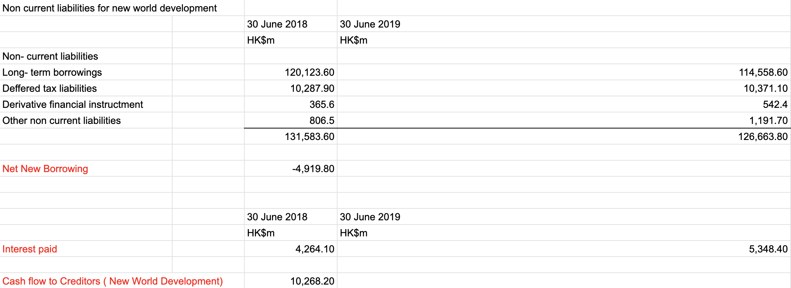

As for New World Development, We have found a wide range of data regarding the cash flow to creditors in two consecutive years, for example, long- term borrowings, deferred tax liability, etc. After that, we use excel, to sum up, all the non-current liabilities items and calculate the Net New Borrowing, which is HK$ -4919.80 million.

After that, we have found the interest paid of New World Development in 2018 and 2019, which is HK$ 4264.1 million and HK$ 5348.4 million respectively. By using the formula stated above, Cash Flow to Creditors = Interest paid - Net New Borrowing, we can calculate that the cash flow to creditors for New World Development would be HK$ 10,268 million.

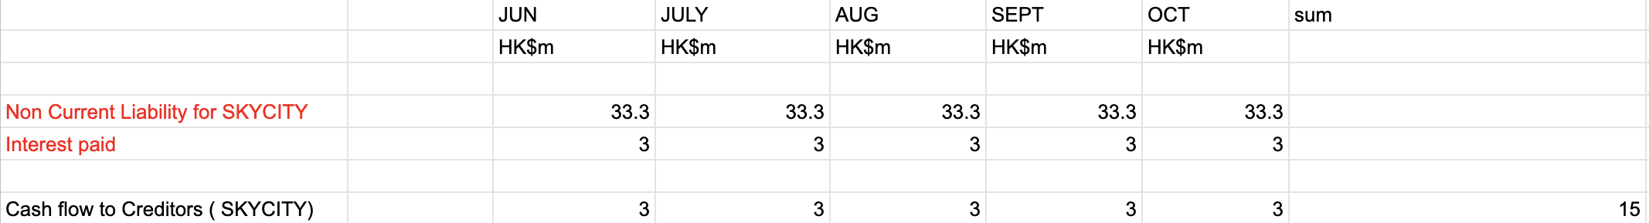

As for the project SKYCITY, We can find out that the loan to construction cost ratio for New World Development is 80%. However, given the current unstable situation in Hong Kong, the company would prefer using more internal resources than borrowing external debt. Therefore, we assume that the company will lower loan to construction ratio to 40%, which means that it will borrow HK$ 8 billion for the project and use HK$ 12 billion from its internal resources. Moreover, we assume that the interest rate is about 9 % annually because of the poor business environment in Hong Kong recently, and the company will repay the long term loan within 20 years. After calculating by excel, we can know that the non-current liability for SKYCITY and the cash flow to creditors for the project would be HK$ 33.3 billion and HK$ 3 million respectively.

**b) Cash Flow to Shareholders**

We use the data of NWD to estimate the data for this project.

Cash Flow to Shareholders = Dividend Paid – Net New Equity Raised

For NWD, we can find the following data, which is associated with the dividend paid and net new equity paid, from annual reports of NWD and data provided by Morningstar, Inc. Since the fiscal year used by New World Development is from 1 July to 30 June, we choose the time point 30 June to analyze the data of NWD.

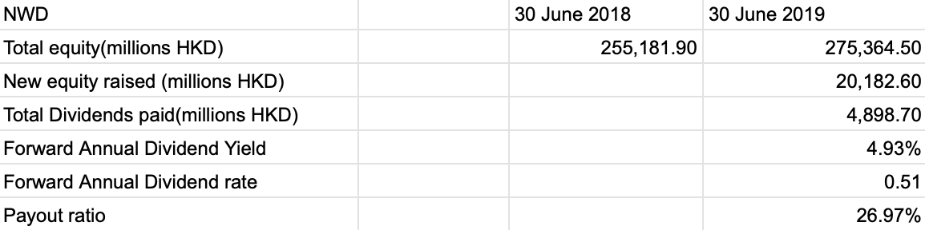

For this project, we can get dividend paid for this project through net income and payout ratio. We assume that the construction is finished and it is operating normally. With this prerequisite, although the net new equity raised by NWD is high, we consider that the part of it invested in this project is small. Thus, we get the cash flow to shareholders for this project.

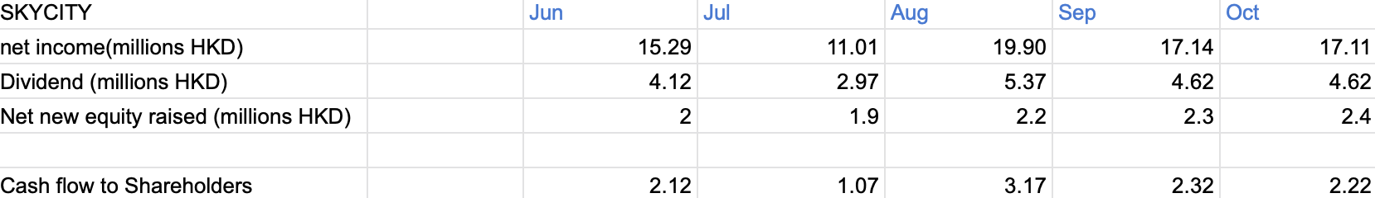

**c) Cash Flow from Assets**

Cash Flow from Assets = Operating Cash Flow – Net Capital Spending – Change in Net Working Capital

Operating cash flow=EBIT+Depreciation-Taxes

Net capital spending=Ending net fixed assets- Beginning net fixed assets+depreciation

Change in NWC=Ending NWC-Beginning NWC

SkyCity can be separated into 2 phases: one is the retail complex where sports, dining, and entertainment are provided and the other one is the office for rent. Each phase shares the same area and the total area of this project is 25 hectares according to the given assumption.

The revenue for this project is from retail, rental income from office and the parking charge. The expense is from property operating, depreciation and salary.

**(1) Revenue**

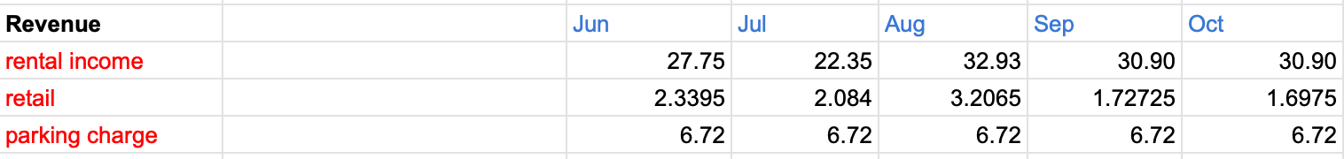

(i) Rental income:

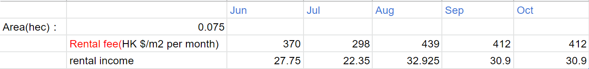

Considering the location where the Skycity is (i.e. Chep Lap Kok) is not a popular business district like Central, it can be assumed that the rental fee of office in Skycity is the same as what it is in Kowloon which can be found in the government document. Besides, taking the location of Skycity and the noise of the airport into consideration, it can be assumed that only 60% of the office is rented. Thus, the rental income of this project can be calculated.

(ii) Parking charge:

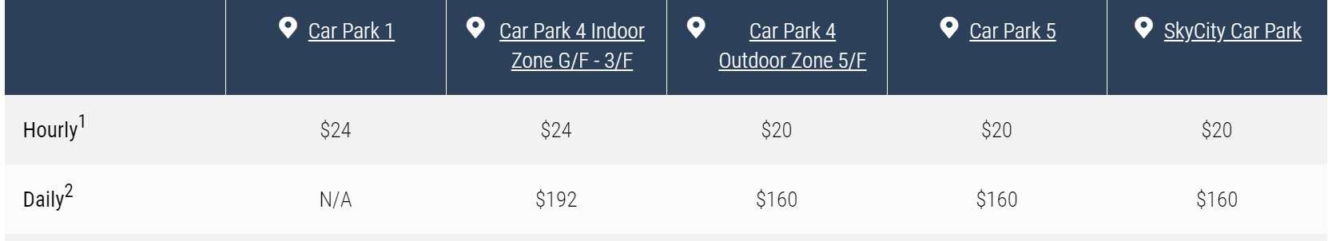

Taking the charging fee that is provided by the Hong Kong International Airport into consideration, it can be assumed that 80% of the parking spaces in Skycity are occupied for 24 hours each day while there are 2800 parking spaces. As a result, the parking charge can be found.

(iii) Retail:

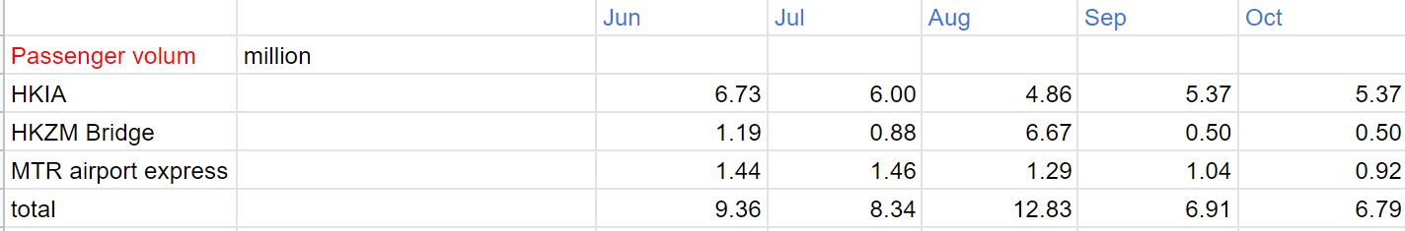

According to the location of Skycity, it can be concluded that there are 3 main sources of passenger flow: from Hong Kong International Airport, Hong Kong-Zhuhai-Macau Bridge and MTR airport express. Thus, the passenger flow volume in Skycity can be found. Since Skycity is at the transportation junction, it can be assumed that 1% of these passengers will choose to visit the dining/retail/entertainment area of Skycity and 5% of the visitors are willing to do the consumption. Assume the lowest consumption is 0 and the highest is 10,000. Suppose that the number of people arriving at the mall in a certain period, N, obeys the Poisson distribution with a parameter of , and the consumption of each customer in the mall, X, obeys the uniform distribution on [a,b]. The consumption of each customer is independent of each other and independent of N. So the sale should be. For discrete random variables, the function expectation formula is E (g(X)) =. Due to the equation E(X)=E(E(X|Y)), E(S)=E(E(S|N))= E(E(|N)). Let g(X)=E(, so E(g(X))= . Due to the fact that X is independent of N, E (|N)= E(). So the total amount of consumption is =E(x) =E(x) E (N)=. Having found the relationship between consumption and the number of consumers, the retail revenue of Skycity can be found.

**(2) Expenses**

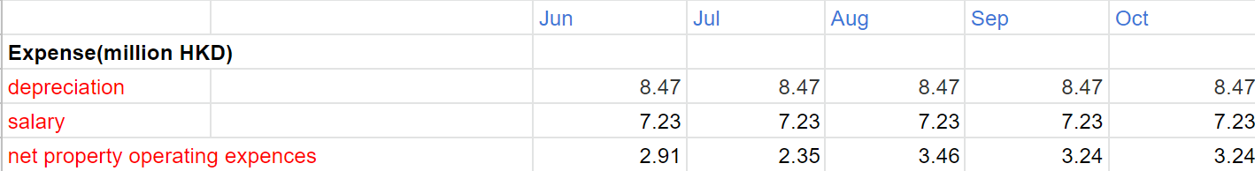

(i) Salary:

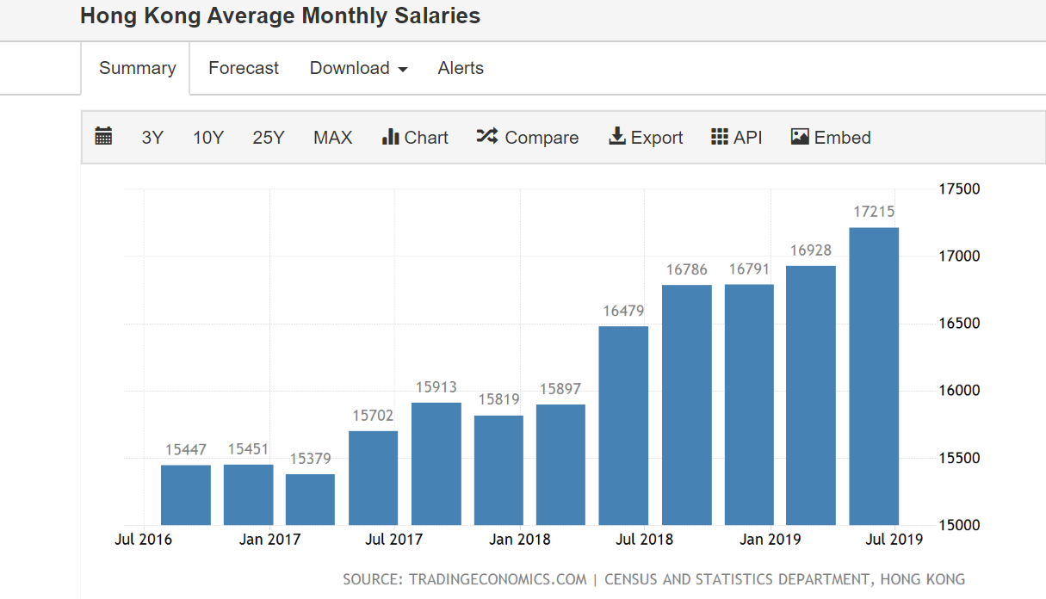

Taking the New Town Plaza in Shatin as an example, there are 3 floors with around 70 stores on each floor. Assuming there are 2 employees in each store and they earn the average wage in Hong Kong, the expense for salary can be found.

(ii) Depreciation:

It can be assumed that the initial cost of the asset is 20 billion, the salvage value is 10 million and there is straight-line depreciation. As a result, it can be found that the depreciation each year is 42.34 million HK dollars.

(iii) Tax:

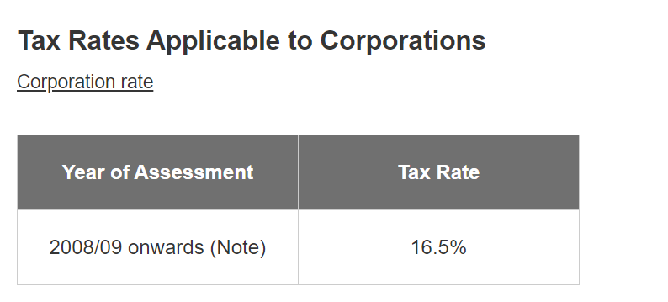

According to the Tax Rates Applicable to Corporations provided by the government which is 16.5%, we can calculate the tax of this project.

Net property operating expenses (including the post-construction fee):

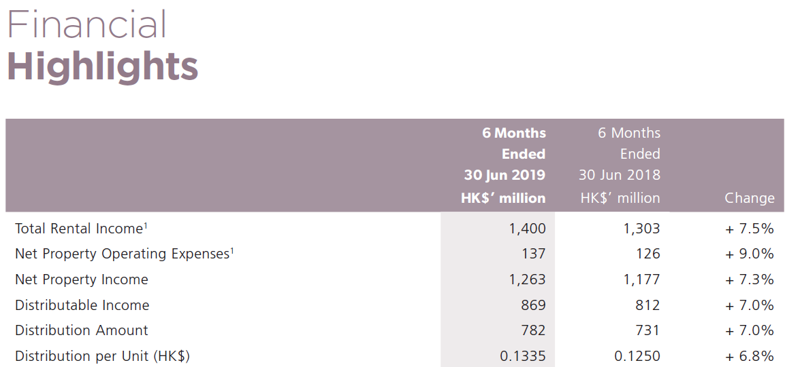

It includes the expense of cleaning, maintaining, etc. Taking the Champion Real Estate Investment Trust as an example, their ratio of net property operating expense to rental income is 10.5% which can be applied when calculating the net property operating expenses of Skycity.

**(3) Change in NWC**

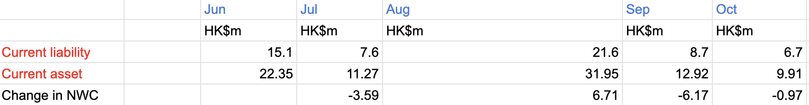

By browsing the YAHOO FINANCE webpage, we know that the Debt-equity Ratio and Current ratio of New World Development are 56.99% and 1.48 respectively. We assume that the project SKYCITY has the same ratio as New World Development. As calculated in cash flow to creditors, the non-current liabilities for SKYCITY would be HK$ 33.3 billion. By using the Debt-Equity ratio, (Current liability + Non- Current liability)/ Total Equity = 0.5699, we can calculate the current liability is HK$ 15.1 million, 7.6 million, 21.6 million, 8.7million, and 6.7 million for June, July, August, September, and October respectively.

After that, by using the current ratio, Current Asset = Current Liability* 1.48, we can calculate the current asset for the project SKYCITY is HK$ 22.35 million, 11.27 million, 31.95 million, 12.92 million, and 9.91 million for June, July, August, September and October respectively.

Lastly, the change in Net Working Capital can be calculated by the equation, ( Ending Current Asset- Ending Current Liability) - (Beginning Current Asset- Beginning Current Liability), we can know the Change in Net Working Capital for July, August, September and October is HK$ -3.59 million, 6.71 million, -6.17 million and -0.97 million respectively.

**4.Best, Base and Worst Scenario**

**(a) Base scenario**

In the base situation, we would have 60% of the rented area being occupied. (Around 0.075 hec) In addition, half of the parking area would be in use. And the monthly parking charge was HK$ 6.72 million. The retail revenue would remain stable as the chart below.

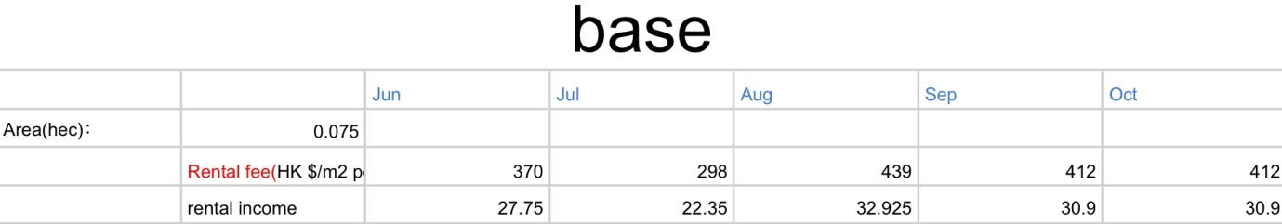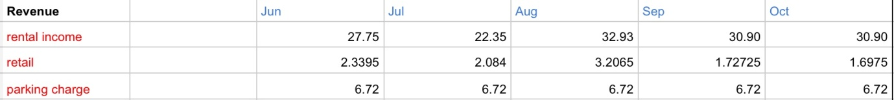

**(b) Best scenario**

In an extremely good situation, we make the following assumptions. 100% of the offices had a rental relationship with other companies. It took around 0.125 hec floor area. Thus, all the monthly rental income would increase by 40% more than the base scenario. Besides, the parking charge would double as the parking area was assumed to be fully occupied. Finally, consumers would have doubled. As a result, the retail revenue would be twice as much as the base scenario. 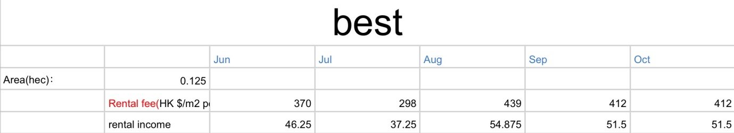

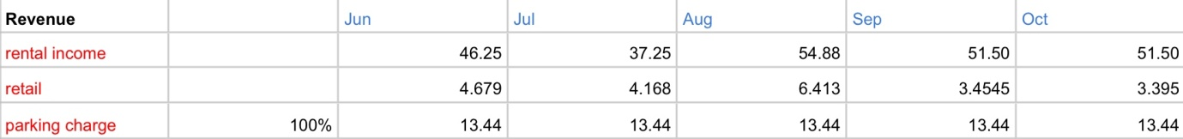

**(c) Worst scenario**

Due to the political instability, we assume that only 30% of offices and rooms (0.0375 hec) would operate normally so that the rental revenue would reduce accordingly. The parking area in use would drastically drop to 25% of the total, followed up by the decreasing parking charge. Further, the retail market was largely affected. Fewer tourists were able to come to Hong Kong through all kinds of traffic channels. We would have lost 50% of the consumers. Consequently, the retail revenue would reduce to half compared to the base assumption. 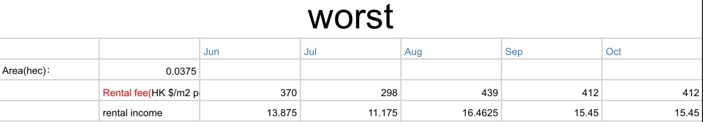

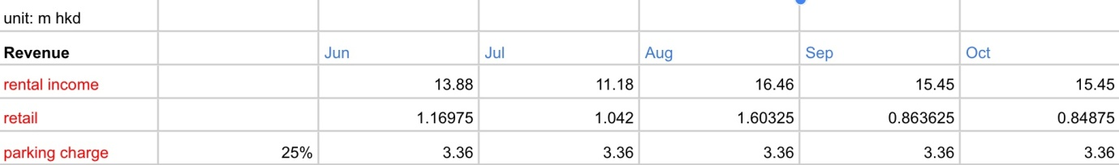

**(d) Project cash flows and NPV**

The project cash flow (operating cash flows) during these five months is demonstrated in the chart below. When the discount rate remains at 15%, the NPV of different cash flow is calculated as HK$ -17320,520,000 (base), HK$ -17,256,840,000(best) , HK$ -17,362,790,000(worst).

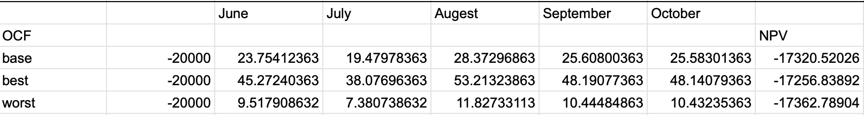

**5.IRR and Loss**

**(a) IRR**

By using the IRR excel formula, we found that under the three conditions, the IRR are all negative. They are -72%, -68% and -77% separately. Therefore, we conclude that the Skycity was unable to achieve a positive IRR from June to November 2019.

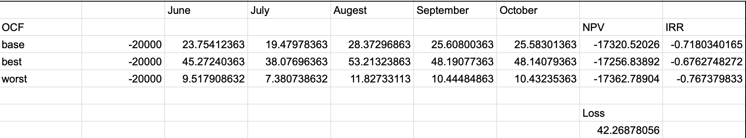

**(b) Loss**

If the business ran in a normal situation, the NPV would be like the base situation. However, our company might be close to the worst situation. Thus, we subtract the base scenario NPV with the worst scenario NPV. The loss that our company has suffered might be HK$ 42,268,780.

1. **References**

Annual reports of New World Development retrieved from <https://cms.nwd.com.hk/downloadIR/report/170/ltn20191018085_en_0.pdf> and <https://cms.nwd.com.hk/downloadIR/report/167/EW00017_0.pdf>

Champion Real Estate Investment Trust. (2019). Financial reports. Retrieved from <https://www.championreit.com/investor-relations/financial-reports>

Chen, F. (2019).Underused mega-bridge hungry for traffic. Retrieved from <https://www.asiatimes.com/2019/10/article/underused-mega-bridge-hungry-for-traffic-as-competition-looms/>

HKSAR Rating and Valuation Department. (2019). Property market statistics. Retrieved from <https://www.rvd.gov.hk/en/property_market_statistics/index.html>.

Hong Kong International Airport. Parking charges. Retrieved from <https://www.hongkongairport.com/en/transport/parking/parking-charges.page>

Hong Kong International Airport. SKYCITY. Retrieved from <https://www.skycityhongkong.com/en/>

Hong Kong Interest Rate (2019).

<https://tradingeconomics.com/hong-kong/interest-rate>

Hong Kong International Airport. (2019). Facts and figures. Retrieved from <https://www.hongkongairport.com/en/the-airport/hkia-at-a-glance/fact-figures.page>

Island Revenue Department. (2019). Tax Rates of Profits Tax. Retrieved from <https://www.gov.hk/en/residents/taxes/taxfiling/taxrates/profitsrates.htm>

Kwan S. (2018). Hong Kong developer New World Development to invest US$2.5b in Skycity airport retail complex. Retrieved from

<https://www.mingtiandi.com/real-estate/projects-real-estate/new-world-development-wins-2-5b-airport-commercial-project/>

[Leung](https://www.scmp.com/author/kanis-leung), K. (2018). Hong Kong-Zhuhai-Macau Bridge traffic continues to rise, but efforts to reduce weekend day-trippers pay off. Retrieved from [https://www.scmp.com/news/hong-kong/hong-kong-economy/article/2179456/hong-kong-mega-brid ge-traffic-continues-rise](https://www.scmp.com/news/hong-kong/hong-kong-economy/article/2179456/hong-kong-mega-bridge-traffic-continues-rise)

New Town Plaza. (2017). Floor plan. Retrieved from <https://www.newtownplaza.com.hk/shopping>.

New World Development. (2019). Financial reports. Retrieved from <https://cms.nwd.com.hk/downloadIR/report/170/ltn20191018085_en_0.pdf>

Trading Economics. (2019).Hong Kong Average Monthly Salaries. Retrieved from <https://tradingeconomics.com/hong-kong/wages>

Yahoo! Finance (2019). NEW WORLD DEV (0017.HK) Valuation Measures & Financial Statistics Retrieved from <https://finance.yahoo.com/quote/0017.HK/key-statistics/>